|  |  |  |  |
| --- | --- | --- | --- |
| **Project 1** | | | |
| **Topic:** | Module 1: Working with Data | **Week No. 1** |  |
| **Course Code:** | ITEP203 | **Term:** | 1st Semester |
| **Course Title:** | **Quantitative Method including Modeling and Simulation** | **Academic Year:** | 2020-2021 |
| **Student Name** |  | **Section** |  |
| **Due date** |  | **Points** | **50** |

**Project Introduction**

This project is aimed at analysis using data visualization in Tableau. Watch the video here to learn what your project is all about!

**Project description**

A large part of working with data is being able to interpret data visualizations and explain your insights to others. To give you some practice with this, we’ve selected a few Tableau dashboards for you to explore. The links are below, under "Choose from these Dashboards." Choose one of these dashboards, whichever one interests you the most, and find three insights in the visualizations. For each insight, provide a static image that shares what you found. Write a short report explaining each observation and how you found the information to reach your conclusion from the dashboard. Altogether (including images), your report should be 1-2 pages.

**Example**

For example one insight might look like:

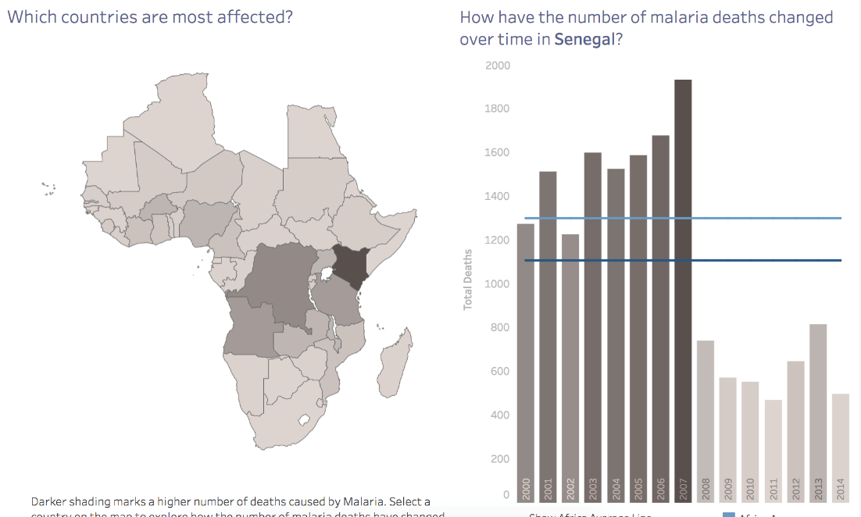

“Deaths per year due to malaria in Senegal have been halved since 2007. From that dashboard, I clicked on Senegal on the map, this showed deaths due to malaria for each year from 2000 to 2014. Before 2007, there were about 1400-1500 deaths per year. After 2007, starting in 2008, deaths were reduced to about 600-700 per year.”

Submit this report as a PDF. All the images and your summary should be in one PDF with each summary following the image of the insight.

**Choose from these dashboards**

[Madrid in Detail](https://public.tableau.com/en-us/s/gallery/madrid-details?gallery=featured)

[Malaria in Africa](https://public.tableau.com/en-us/s/gallery/malaria-africa?gallery=featured)

[LinkedIn Top Skills](https://public.tableau.com/profile/matt.chambers#!/vizhome/LinkedInTopSkills2016-MakeoverMonday/LinkedInTopSkills2016-MakeoverMonday)

If you choose to work with the LinkedIn data, you may find [this article](https://blog.linkedin.com/2016/10/20/top-skills-2016-week-of-learning-linkedin) helpful for the insights that you draw.